PROJECT REPORT

The Tragedy of flight: A comprehensive crash analysis

1. Introduction

1.1 Overview

When a plane crash occurs, it is important to conduct a thorough analysis to determine the cause or causes of the accident. This is done to improve safety and prevent future accidents from happening.

The crash analysis of a flight typically involves several stages, including: Initial investigation, Black box data analysis, Aircraft reconstruction, Human factors analysis and the final report.

The crash analysis of a flight can take months or even years to complete. The goal is to identify the cause or causes of the accident so that steps can be taken to prevent similar accidents from happening in the future.

1.2 Purpose

The purpose of conducting a crash analysis of a flight is to investigate the circumstances and factors that led to the accident, with the aim of identifying the root causes and contributing factors that can be addressed to prevent similar accidents in the future. The analysis may involve multiple organizations and stakeholders, including the airline or aircraft operator, the aircraft manufacturer, regulatory bodies, and other experts in aviation safety.

Overall, the purpose of the crash analysis is to learn from the tragedy and take steps to prevent similar accidents in the future, ultimately making air travel safer for passengers and crew.

2. Problem definition and design making:

2.1 Empathy map

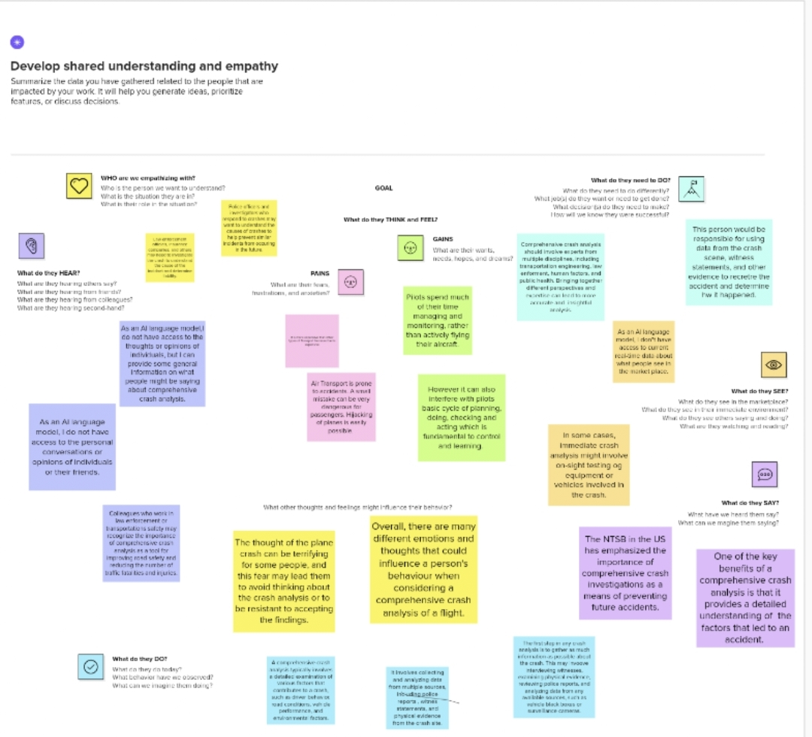

2.2 Ideation and Brainstorming map

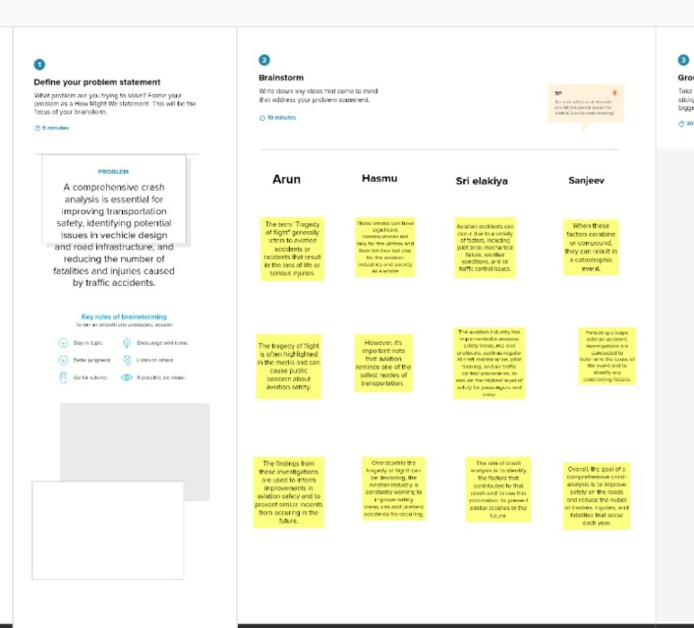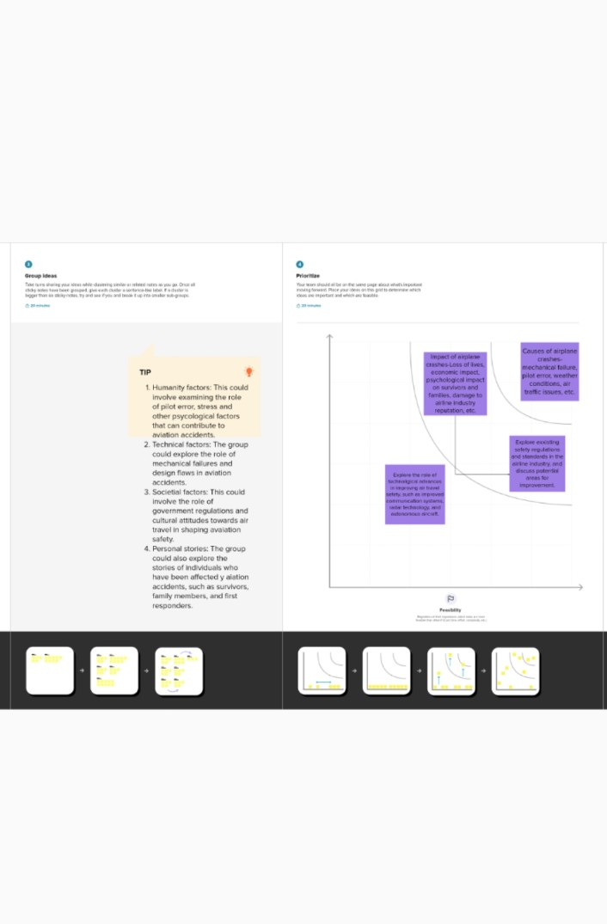

3. Result

Activity and Screenshot

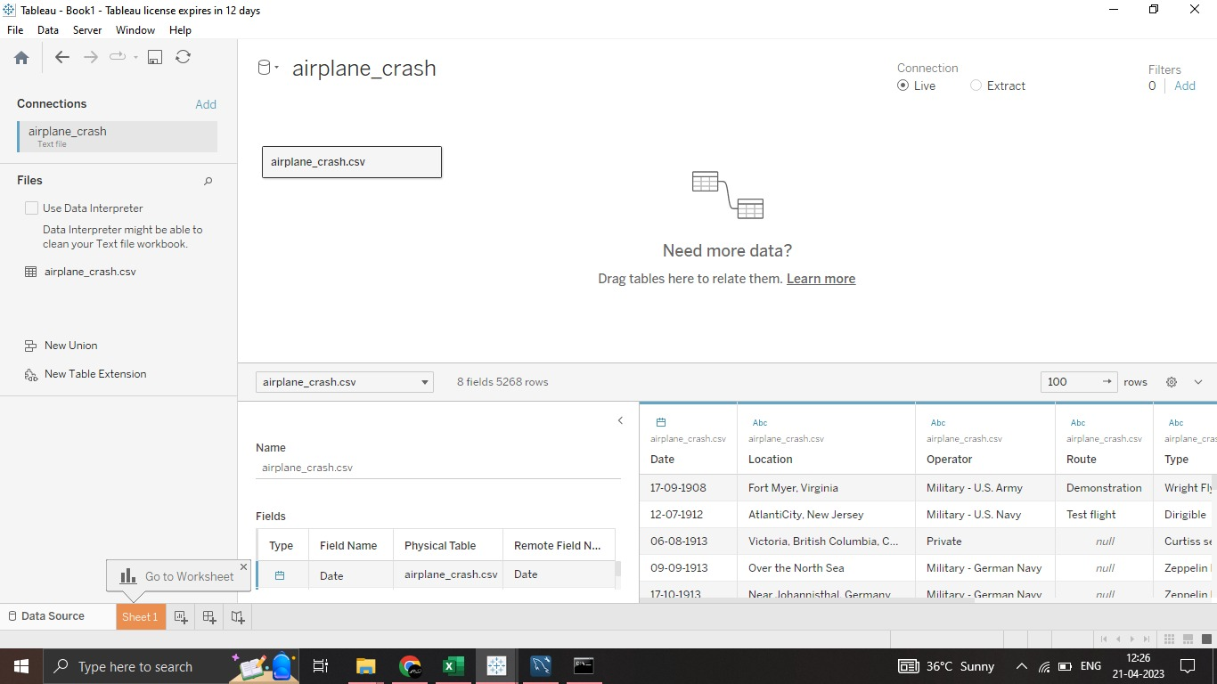

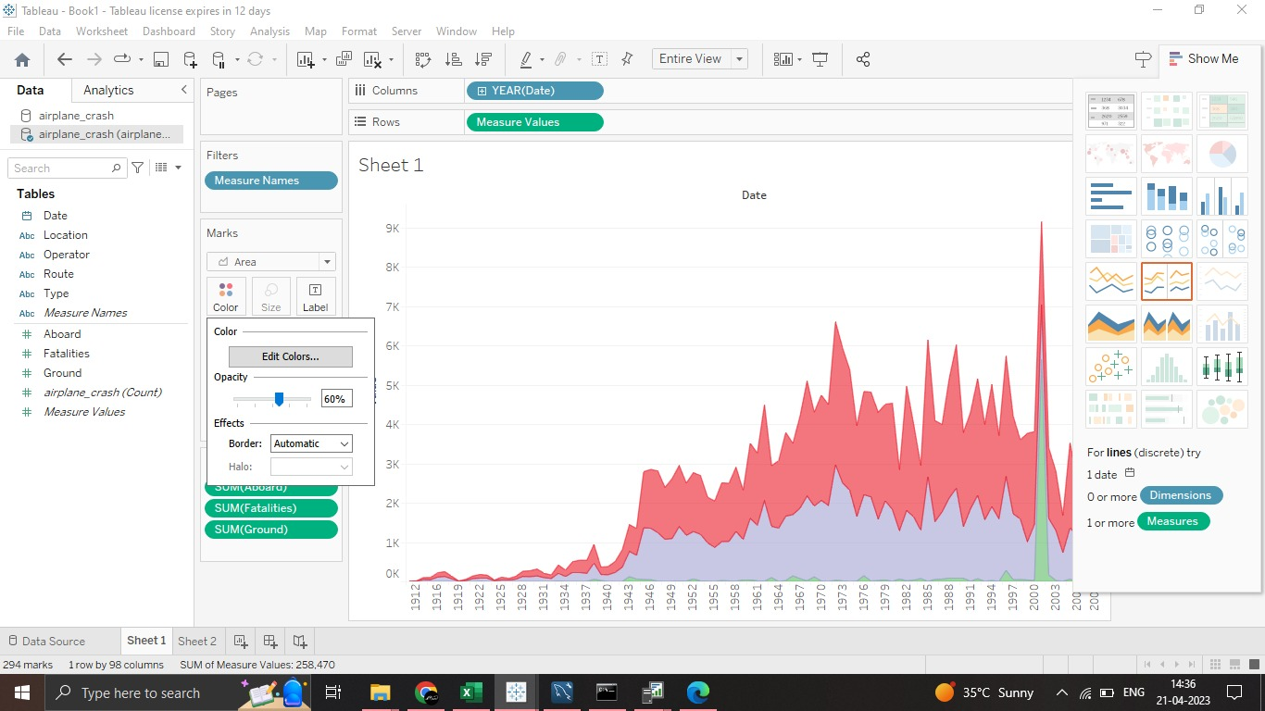

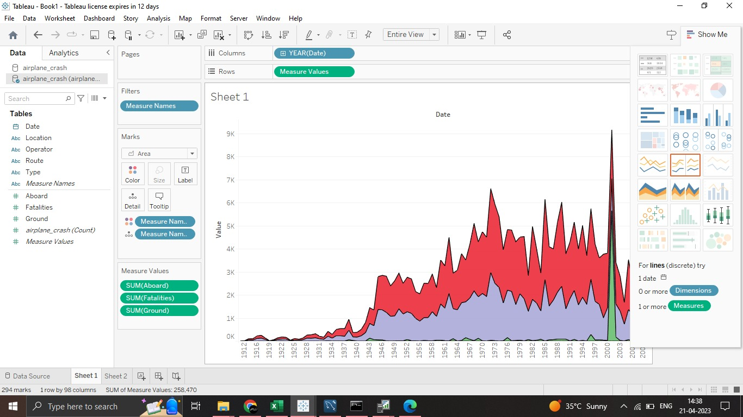

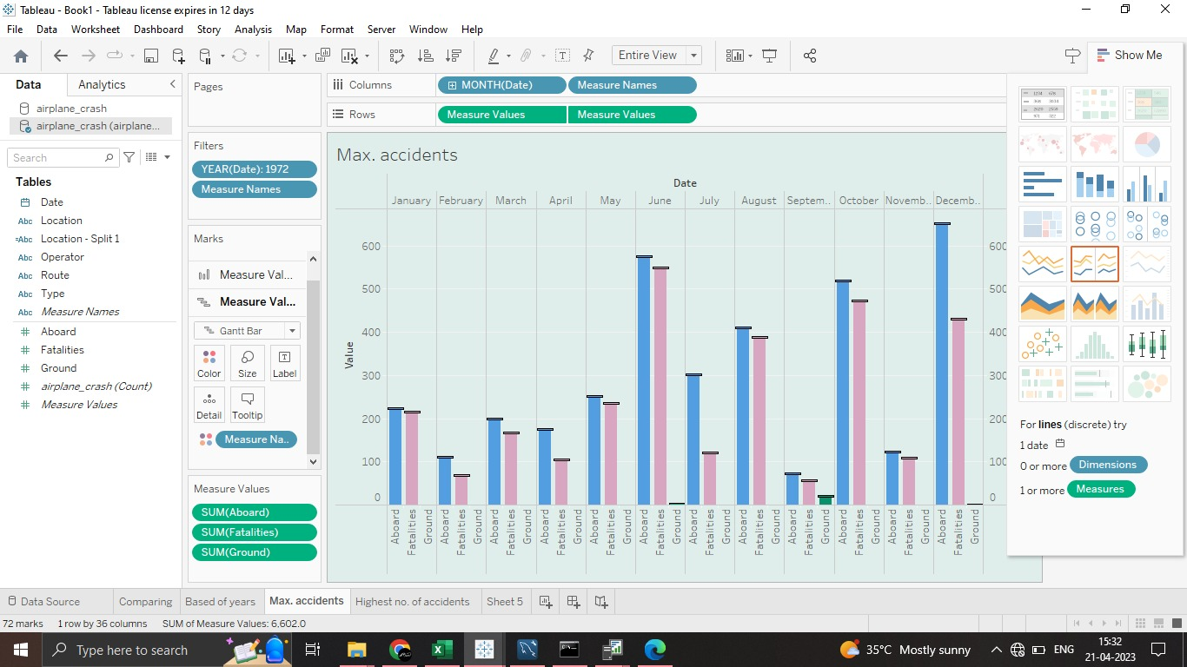

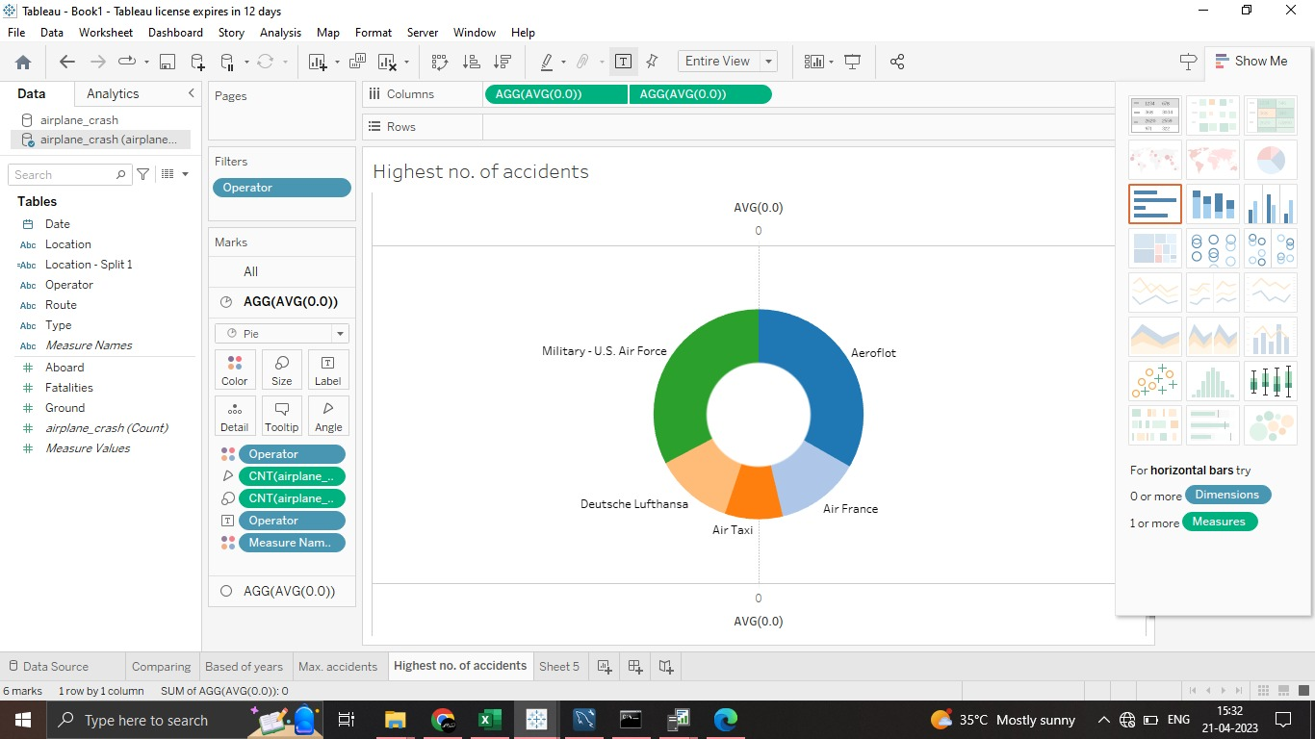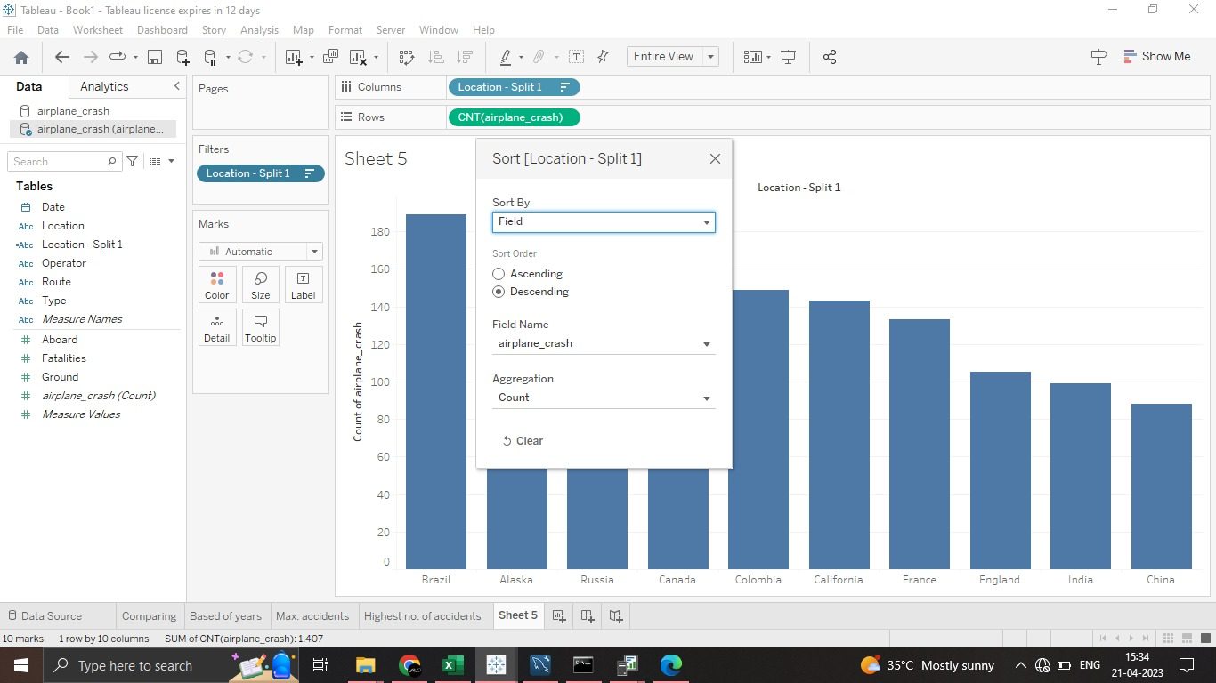

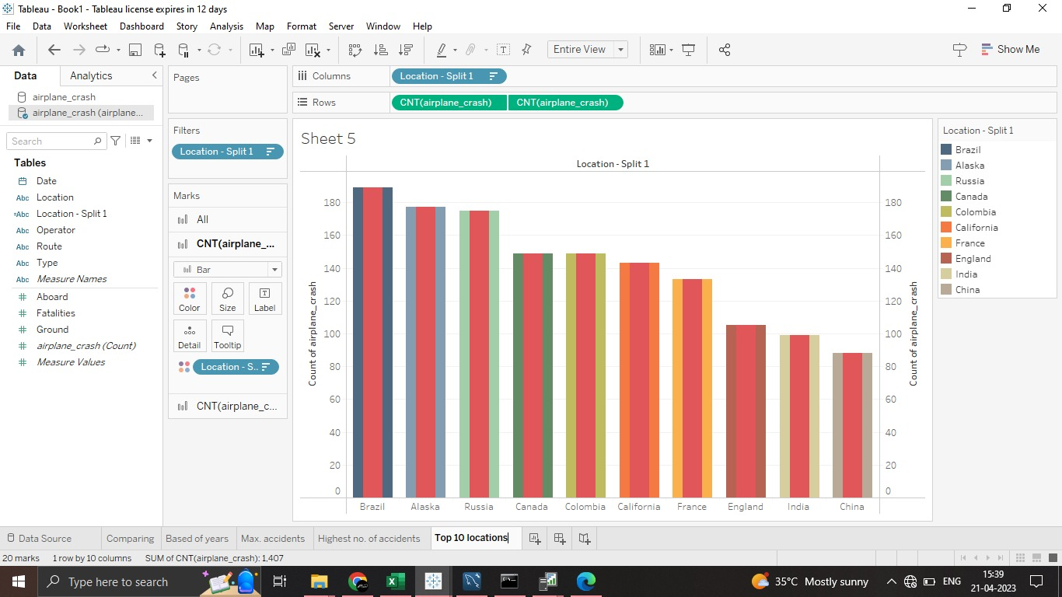

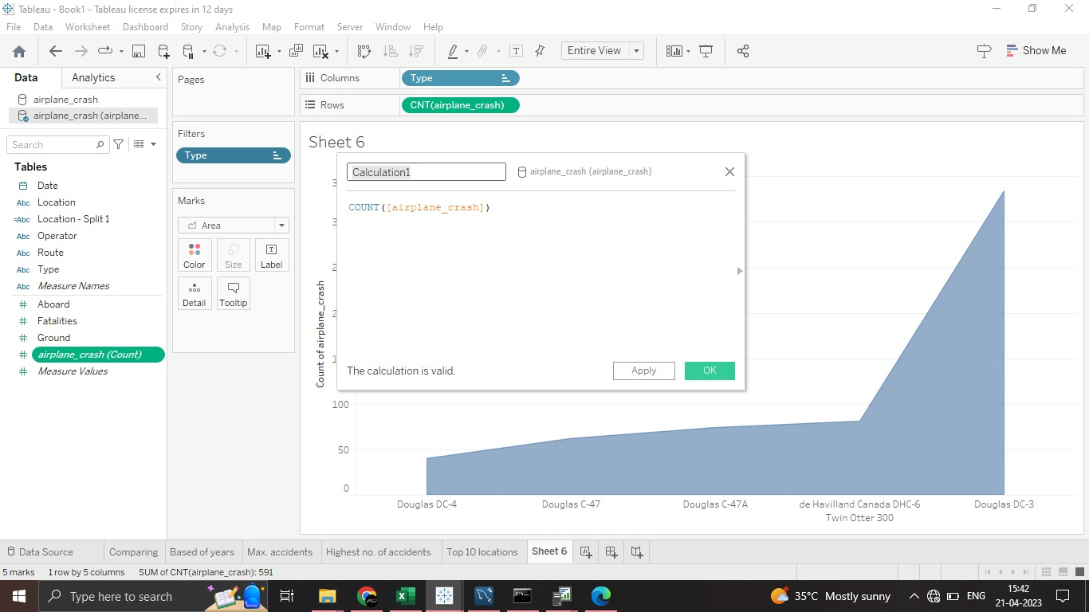

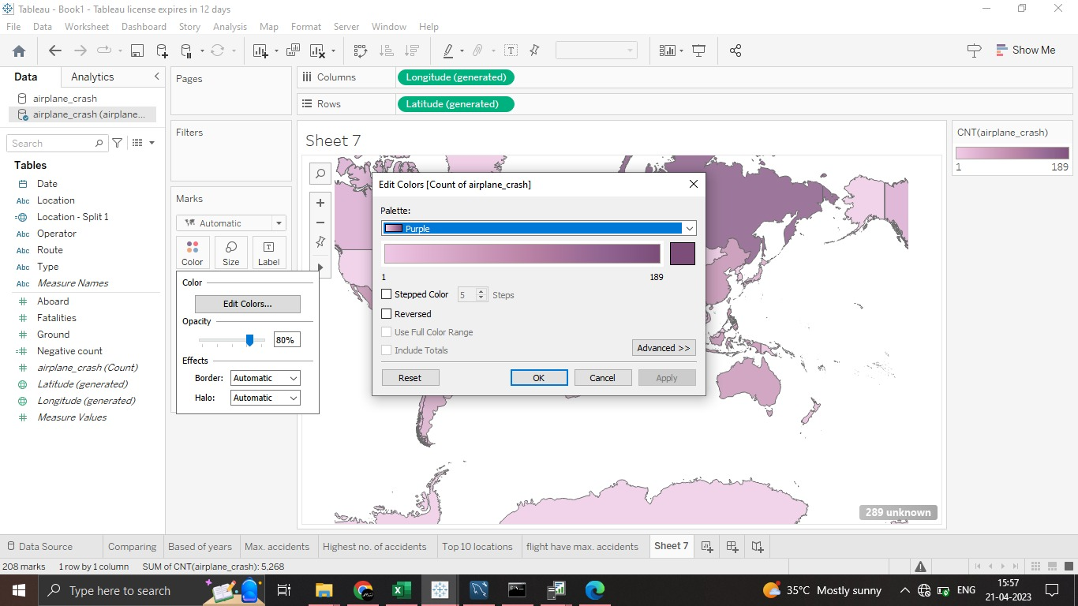

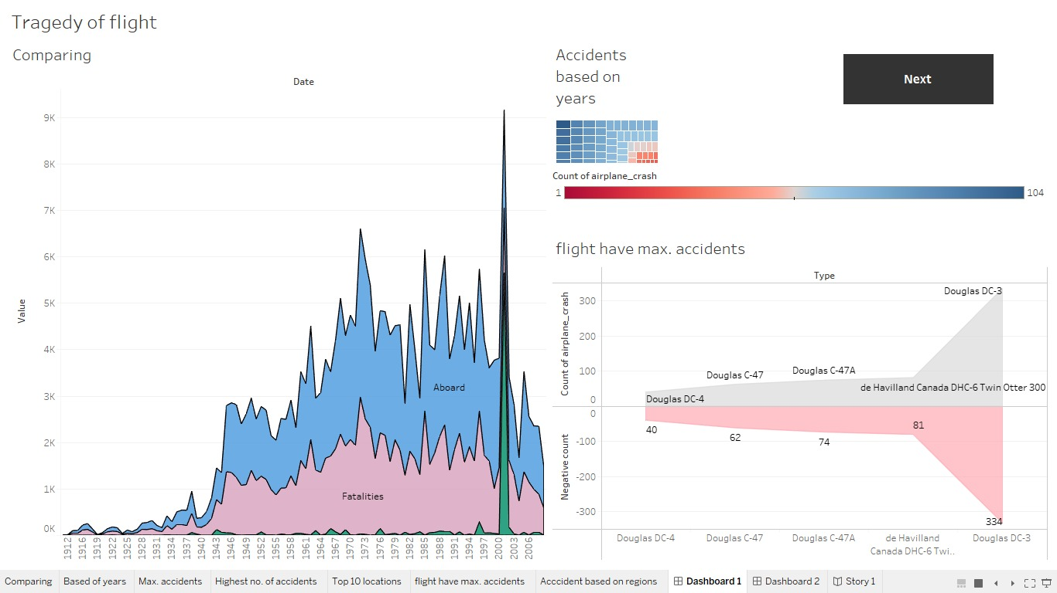

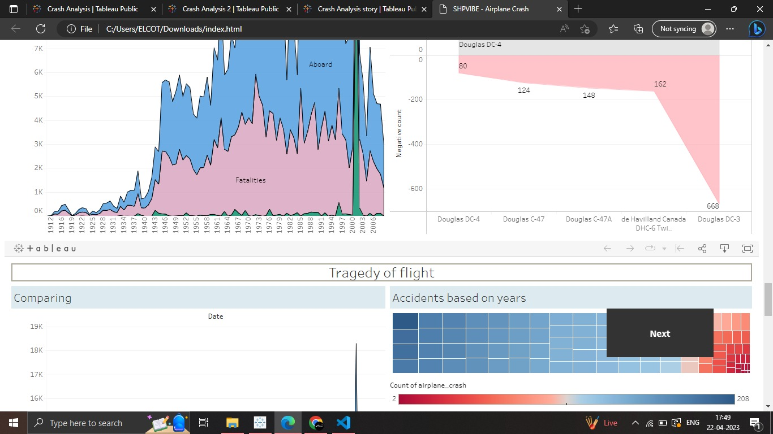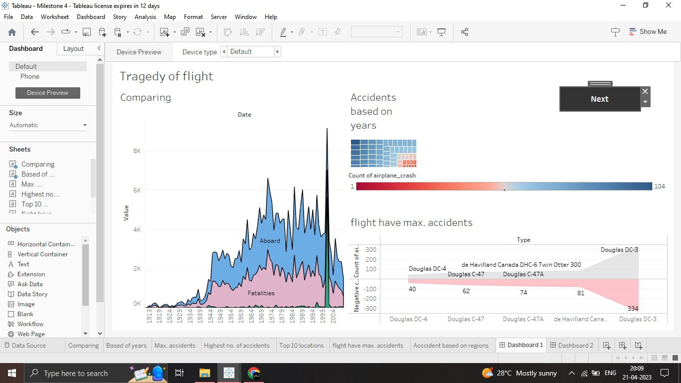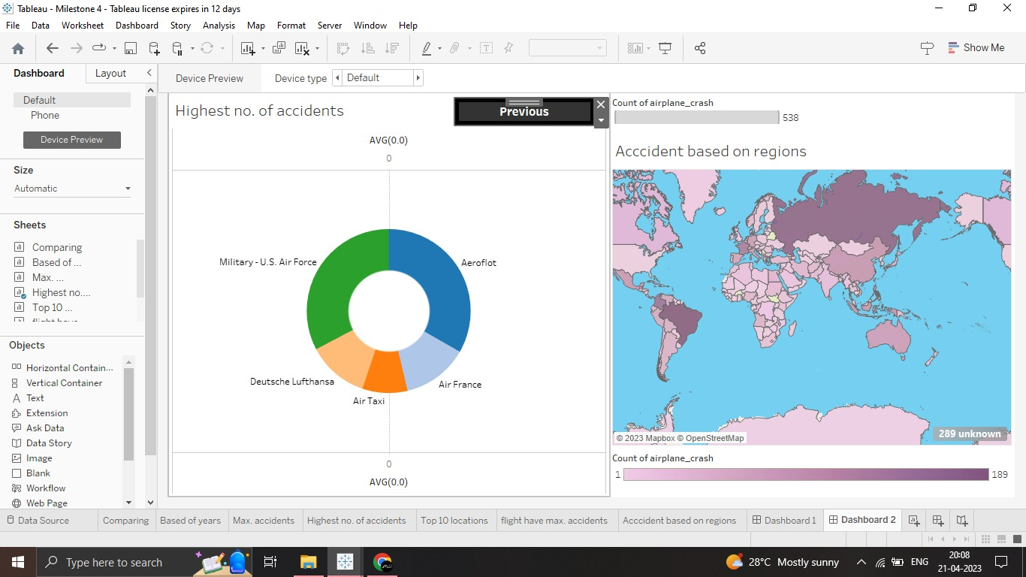

4. Trailhead profile public URL

Team lead: <https://trailblazer.me/id/arun2563>

Team Member 1 - <https://trailblazer.me/id/hasmu30>

Team Member 2 - <https://trailblazer.me/id/srielakiya14>

Team Member 3 - <https://trailblazer.me/id/sanjeev09>

5. Advantages and Disadvantages:

Advantages:

* Identifying the cause of the crash
* Improving aircraft design
* Enhancing aviation regulations
* Improving pilot training
* Providing closure for families

Disadvantages:

* Limited data
* Time consuming
* Conducting an analysis can be costly
* Emotionally challenging for the families
* Technical complexity
* Political considerations

6. Applications:

The application of crash analysis of flight is primarily to improve safety in aviation. Some specific applications are:

1. Aircraft design
2. Maintenance procedures
3. Pilot training
4. Air traffic control procedures
5. Regularity changes

It helps the industry learn from past mistakes and make changes that reduce the risk of future accidents.

7. Conclusion

A conclusion about the tragedies of the flight would involve several key points,

1. Firstly, the investigation would have identified the causes of the crash, such as mechanical failure, human error, weather conditions, or other factors.
2. These may include changes to operating procedures, equipment upgrades, or additional training for pilots and crew members.
3. The report may also discuss any legal or regulatory implications of the crash, such as liability or changes to aviation regulations.

Overall, the conclusion of a crash analysis project is focused on understanding what went wrong and how to prevent it from happening again in the future, with the goal of improving safety and reducing the risk of future accidents.

8. Future scope

As data analytics and technology, the future scope continuing to advance,

* Improved data collection
* Advanced simulation tools
* Artificial Intelligence in identification
* Integration with other data sources
* Real time monitoring

The future scope is likely to involve increased use of advanced technology and data analytics to improve the accuracy and efficiency of crash analysis.

9. Appendix Code

Dashboard 1:

<https://public.tableau.com/views/CrashAnalysis_16821619376960/Dashboard1?:language=en-US&publish=yes&:display_count=n&:origin=viz_share_link>

Dashboard 2:

<https://public.tableau.com/views/CrashAnalysis2/Dashboard2?:language=en-US&publish=yes&:display_count=n&:origin=viz_share_link>

Story:

<https://public.tableau.com/views/CrashAnalysisstory/Story1?:language=en-US&publish=yes&:display_count=n&:origin=viz_share_link>